Project Title: Password-Protected Digital Security System Using Logic Gates

Objective
The primary objective of this project is to design and implement a basic yet functional digital security system that utilizes a password mechanism for granting or denying access. This system will employ fundamental digital logic elements—such as logic gates, flip-flops, and LEDs—assembled on a breadboard. The design will simulate a real-world security application where only the correct binary password can enable access, visually indicated using LEDs.

Project Overview
This project aims to develop a 4-bit binary password security system capable of validating user input against a predefined password. The system will use DIP switches or push buttons to enter the password, and digital logic gates (AND, OR, NOT, XOR) embedded within a comparator IC to verify the input. If the entered password matches the stored one, the system will activate a green LED, signaling "Access Granted." Conversely, any incorrect password will trigger a red LED, indicating "Access Denied."
This implementation not only demonstrates the practical use of combinational logic but also introduces students to real-world applications of digital electronics, input/output control, and system security.

Components Required
- Breadboard – for constructing the circuit
- LEDs – one green (access granted), one red (access denied)
- Comparator IC – a 4-bit comparator containing integrated logic gates (AND, OR, NOT, XOR)
- DIP Switches / Push Buttons – for entering the binary password
- Resistors – to limit current for LEDs and protect components
- Connecting Wires – for circuit connectivity
- 5V Power Supply – to power the breadboard circuit

System Methodology
- Input Mechanism:
Four DIP switches (or push buttons) will be used to enter the binary password. Each switch represents one bit (from MSB to LSB), allowing 16 possible combinations (0000 to 1111).
- Stored Password Configuration:
A fixed 4-bit password will be hardcoded into the circuit using logic levels (either 0 or 1 through direct wiring or pull-up/down resistors).
- Password Comparison:
The XOR gates within the comparator IC will be used to compare each entered bit with the corresponding bit of the stored password:
  - If a bit matches, XOR will output 0.
  - If a bit mismatches, XOR will output 1.
  - The outputs of all XOR gates are fed into a NOR or NAND configuration to determine whether all bits matched.
- Output Response:
  - If all XOR outputs are 0 (indicating a perfect match), the logic circuit outputs a high signal to the green LED (Access Granted).
  - If any XOR output is 1 (indicating a mismatch), the red LED lights up (Access Denied).
- Power Management:
All components will be powered using a 5V DC supply, ensuring safe and reliable operation of digital components and LEDs.

IC Configuration
Detailed configuration of the comparator IC, pinout description, wiring diagram, truth table, and logic equations:
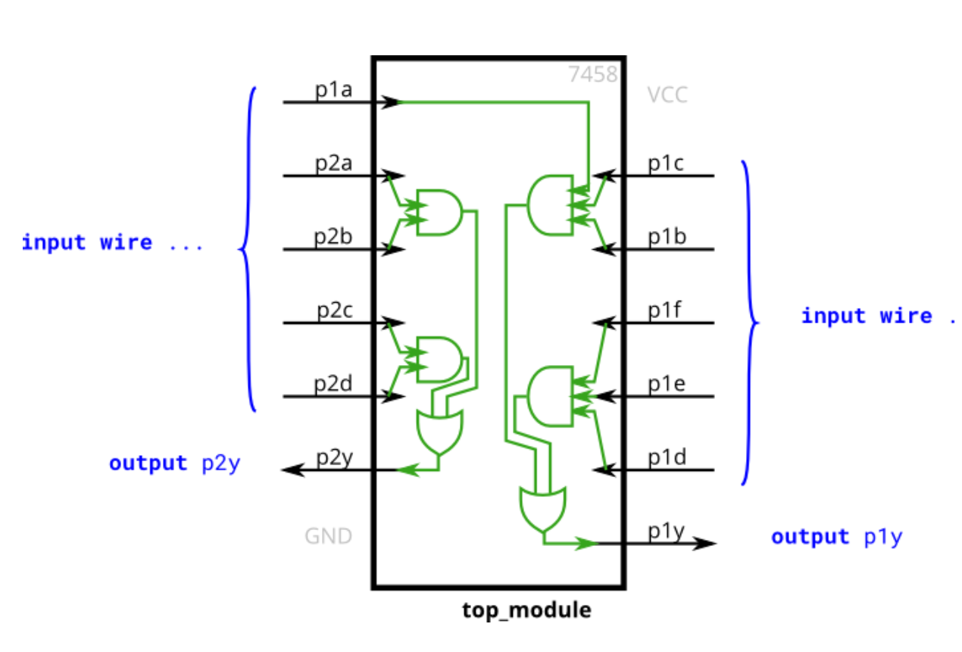

Real-Life Applications
This simple digital logic-based password system finds relevance in various security-sensitive applications, such as:
- Digital Door Lock Mechanisms
- Bank Vault and Safe Security
- Electronic Voting and Ballot Machines
- Personal Digital Lockers
- Restricted Access Panels
- Home Security and Intrusion Alarm Systems

Challenges Faced
During the development and implementation of this digital security system, several challenges may arise, including:
- Signal Noise: Mechanical switches (DIP or push buttons) can generate bounce or noise, which may lead to incorrect input readings.
- Component Limitations: Working with limited gates within a single IC may require creative wiring or combining multiple ICs for full functionality.
- Voltage Fluctuations: Inconsistent power supply or poor wiring can cause unstable LED behavior or false outputs.
- Troubleshooting Errors: Diagnosing mismatched inputs and logic errors without simulation tools can be time-consuming, especially on a physical breadboard.
- Hardcoding Passwords: Since the password is hardcoded using physical connections, changing it requires rewiring, limiting flexibility.

Future Extensions
The current system can be enhanced and expanded in multiple ways for more advanced and practical applications:
- User-Configurable Passwords: Add memory elements (e.g., flip-flops or EEPROM) to allow users to set and change passwords dynamically.
- Multi-Level Security: Introduce multi-step authentication using additional inputs or sensors (e.g., biometric, RFID).
- Microcontroller Integration: Upgrade the logic circuit to a microcontroller-based system (e.g., using Arduino) for more flexibility and complex functionalities like timeouts, logging, or multiple users.
- LCD Display Interface: Add a simple display to show entered input or system status messages.
- Sound Feedback: Integrate a buzzer for audio indicators on success or failure.
- Wireless Access: Implement wireless input methods using Bluetooth or keypad modules to simulate remote access scenarios.
- Tamper Detection: Include logic to detect repeated failed attempts and trigger a lockout or alarm system.

Conclusion
By the end of this project, a fully functional prototype of a password-protected digital access system will be demonstrated on a breadboard. The system will accurately detect correct and incorrect password entries and display corresponding results via LEDs. This project serves as a foundational exercise in digital electronics, reinforcing the principles of:
- Boolean algebra
- Combinational logic
- Input/output signal processing
- Practical circuit implementation

